Yellow Pan Trap Experiment – Supply List

- Plastic yellow bowls (supplied by UCR)
- Whirl-Pak or Ziploc bag
- Unscented soap
- Small, fine-mesh aquarium net
- Squirt bottle
- Disposable pipet (supplied by UCR)
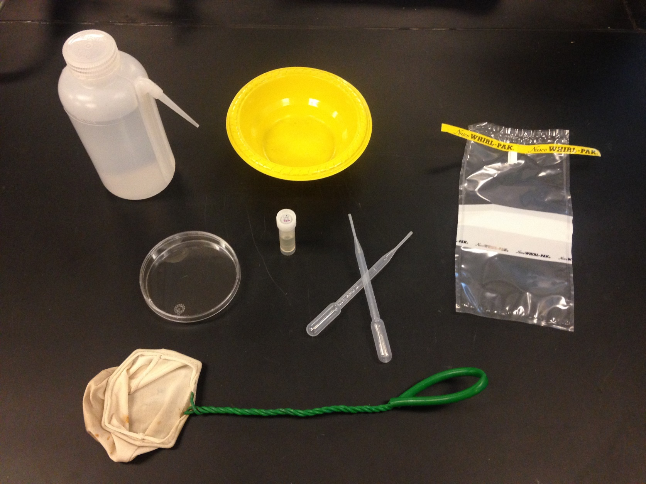
- Petri dishes (supplied by UCR)
6
7
5
4
3
2
1

