Yellow Pan Trap Exercise (Teacher instructions)
Materials:
- Water
- Unscented dish soap
- Stake flags
- Yellow pan traps
- Sharpies
- Clipboards
- Plastic funnels
- Plastic bottles with caps
- Camera/Smart phone

Before class preparations:
1. Solution Preparation Procedure:
For every 400ml add 1 drop of soap
Each pan trap will hold approximately 200ml of solution
- DO NOT ADD TOO MUCH SOAP. The water should still be clear
2. Mark a line roughly 2 cm below top of yellow pan trap, to indicate the max level of water
3. Print out map of school using an image of the school from Google Earth/Google Maps, to plot the locations of the traps.
4. On the map, mark where the high vegetation traps will be placed, and likewise with the low vegetation traps. This will require scouting out possible locations the week prior to this experiment. (This is done to mitigate any issues with what the students may call high vs low vegetation.)
5. Each group will be assigned a low and high vegetation location on campus.

During Class:
1. Students form groups of 3-4 students per group, and are assigned to their locations.
2. Each group is given 6 yellow pan traps, a bottle of trap solution, sharpies, 2 stake flags, 6 plastic bottles, a plastic funnel, clipboards and worksheets.
3. Students will place their traps at the predetermined locations on campus. (Check weather before to make sure no rain will occur for the next few days.) Place traps on any day but Friday.
4. Have students add solution to the traps.
5. Take photo of each trap at the beginning of the experiment.
6. Students will return to the traps 24 hours later to collect specimens.
7. Students will identify and sort the insects using microscopes in the classroom after the traps have been collected and returned.
8. After the students have sorted through all of their traps, gather data from all groups and compile into larger database.
9. Students will observe patterns found with the trap placement

Name _________________________________________ Date__________________

Group Number ___________

Yellow Pan Trap Exercise

Purpose: To evaluate the presence of Hymenoptera diversity on the school campus

Materials: 6 yellow pan traps Trap solution Map of School 6 plastic bottles
Flagging Stakes Permanent marker Plastic funnel
Procedure:
Solution
- Label 3 yellow pan traps as “low” and 3 as “high.” Also label each trap 1, 2, or 3.
- Place 3 traps at the high vegetation location, and 3 at the low vegetation location that your group was assigned.
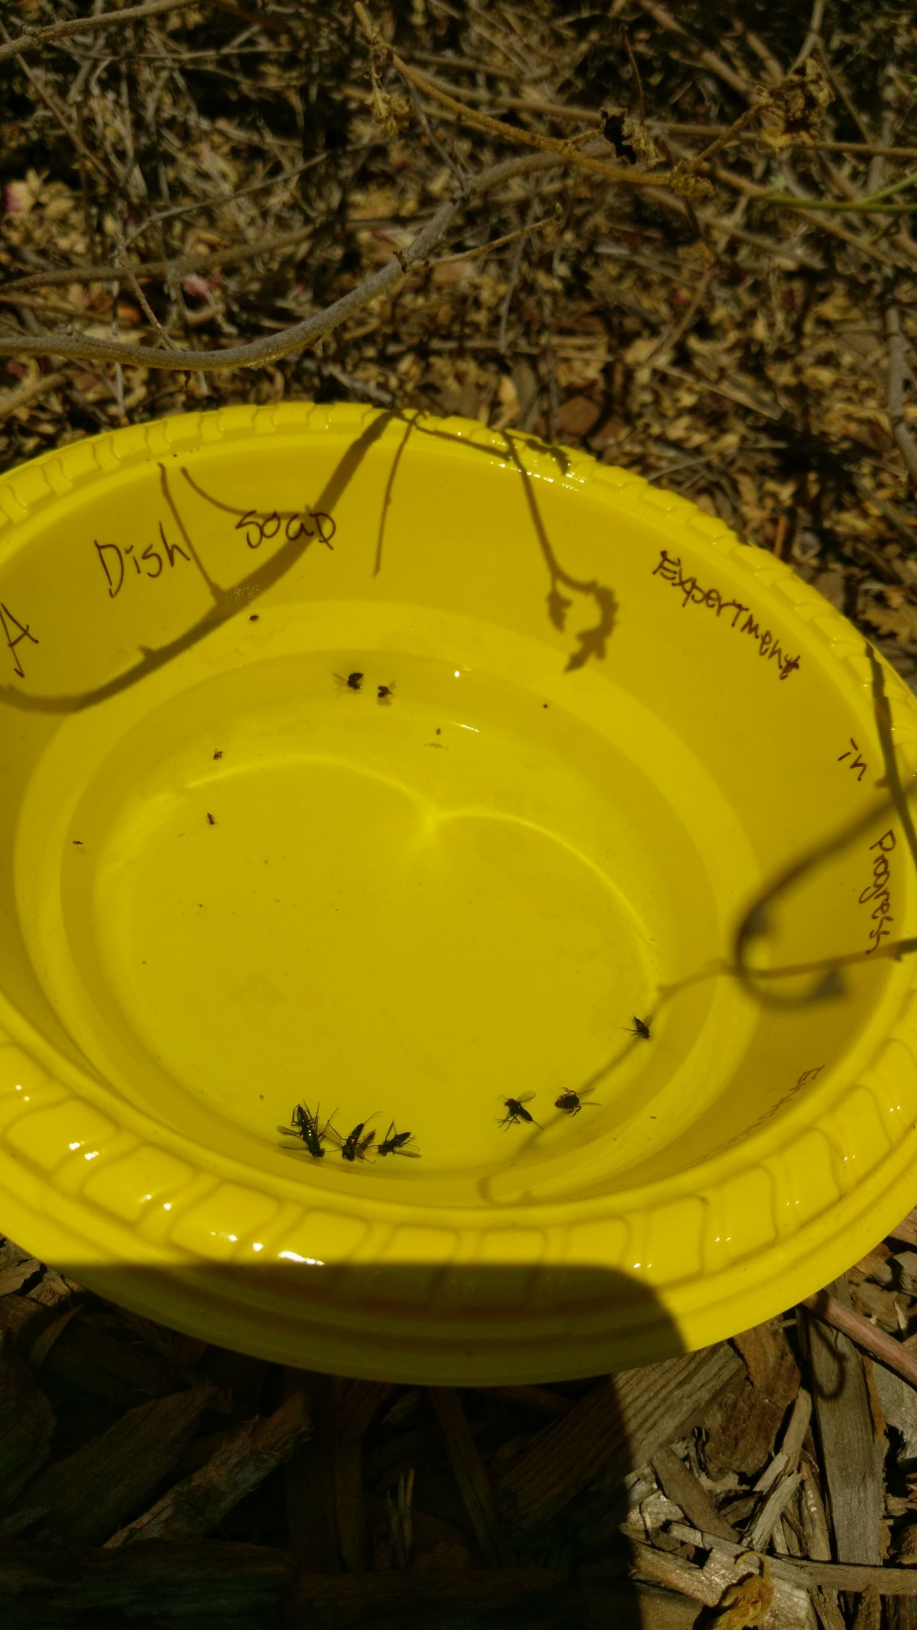
- Fill each trap with solution up to the marked line.
- Write your group number on each of your flagging stakes, and place one stake right next to the traps to warn people of their location.
- Take a photo of each trap, from directly above the trap, right after you fill it with solution.
- Check the trap 24 hours later, and take photos of each trap.
- Label each plastic bottle as “Low-1,” “Low-2,” “Low-3,” “High-1,” “High-2,” “and “High-3.” Pour the contents of each trap through the funnel into the appropriate plastic bottle. Bring the bottles, traps, and flagging stakes back to the classroom.
- Pour each bottle into a sorting tray, one bottle at a time, and place under the microscope to begin sorting the specimens.
- Use the provided keys and pictures to help identify and sort through the insects. Record the numbers of hymenopterans in the worksheet.
- Repeat step 9 with the 5 remaining plastic bottles.
- Return the completed worksheet to the teacher, so that a final count may be made of the traps.

Low-vegetation trap placement: ___________________________________________________________
High-vegetation trap placement: ___________________________________________________________

 | Trap 1 |  |  | Trap 2 |  |  | Trap 3
Location | Predators | Pollinators | Predators | Predators | Pollinators | Predators | Predators | Pollinators | Predators
Low-Veg
High-Veg

Questions

1. What made your locations high or low vegetation? ____________________________________________

_________________________________________________________________________________________________________

_________________________________________________________________________________________________________

2. Did the different locations of traps yield different results? What were the differences?

_________________________________________________________________________________________________________

_________________________________________________________________________________________________________

_________________________________________________________________________________________________________

_________________________________________________________________________________________________________

3. Why do you think there were differences in the locations? Be specific. _____________________

_________________________________________________________________________________________________________

_________________________________________________________________________________________________________

_________________________________________________________________________________________________________

_________________________________________________________________________________________________________

4. Was one group of hymenopterans more numerous than the others? If yes, why do you think this occurred?

_________________________________________________________________________________________________________

_________________________________________________________________________________________________________

_________________________________________________________________________________________________________

_________________________________________________________________________________________________________

_________________________________________________________________________________________________________

5. What would you do to increase the numbers of hymenopterans in a certain area?

_________________________________________________________________________________________________________

_________________________________________________________________________________________________________

_________________________________________________________________________________________________________

_________________________________________________________________________________________________________

